**Assignment No.:09**

**TITLE – 8051 & ADC Interfacing**

**AIM -** Write ALP to interface 8051 with 8/12 bit ADC to 8051 or equivalent and to write a program to find out the average value for 10 readings.

**OBJECTIVE –** To study ADC IC 0804 and 8051 & ADC 0804 interfacing.

**APPARATUS -** 8051 Kit with on board ADC IC 0804, RS 232 Connector, etc.

**THEORY -**

Analog to digital converters find huge application as an intermediate device to convert the signals from analog to digital form. These digital signals are used for further processing by the digital processors. Various sensors like temperature, pressure, force etc. convert the physical characteristics into electrical signals that are analog in nature.

**ADC0804**

**General Description**

The ADC0801, ADC0802, ADC0803, ADC0804 and ADC0805 are CMOS 8-bit successive approximation A/D converters that use a differential potentiometric ladder—similar to the 256R products. These A/Ds appear like memory locations or I/O ports to the microprocessor and no interfacing logic is needed. Differential analog voltage inputs allow increasing the common-mode rejection and offsetting the analog zero input voltage v0alue. In addition, the voltage reference input can be adjusted to allow encoding any smaller analog voltage span to the full 8 bits of resolution.

ADC 0804 is a very commonly used 8-bit analog to digital convertor. It is a single channel IC, *i.e.*, it can take only one analog signal as input. The digital outputs vary from 0 to a maximum of 255. The step size can be adjusted by setting the reference voltage at pin9. When this pin is not connected, the default reference voltage is the operating voltage, *i.e.*, Vcc. The step size at 5V is 19.53mV (5V/255), *i.e.*, for every 19.53mV rise in the analog input, the output varies by 1 unit. To set a particular voltage level as the reference value, this pin is connected to half the voltage. For example, to set a reference of 4V (Vref), pin9 is connected to 2V (Vref/2), thereby reducing the step size to 15.62mV (4V/255).

ADC0804 needs a clock to operate. The time taken to convert the analog value to digital value is dependent on this clock source. An external clock can be given at the Clock IN pin. ADC 0804 also has an inbuilt clock which can be used in absence of external clock. A suitable RC circuit is connected between the Clock IN and Clock R pins to use the internal clock.

**Pin Diagram -**

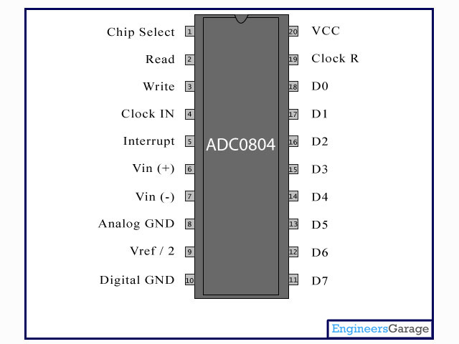

**Fig1: Pin Diagram of 8051**

**Pin Description –**

|  |  |  |
| --- | --- | --- |
| **Pin No** | **Function** | **Name** |
| 1 | Activates ADC; Active low | Chip select |
| 2 | Input pin; High to low pulse brings the data from internal registers to the output pins after conversion | Read |
| 3 | Input pin; Low to high pulse is given to start the conversion | Write |
| 4 | Clock Input pin; to give external clock. | Clock IN |
| 5 | Output pin; Goes low when conversion is complete | Interrupt |
| 6 | Analog non-inverting input | Vin(+) |
| 7 | Analog inverting Input; normally ground | Vin(-) |
| 8 | Ground(0V) | Analog Ground |
| 9 | Input pin; sets the reference voltage for analog input | Vref/2 |
| 10 | Ground(0V) | Digital Ground |
| 11 | 8 bit digital output pins | D7 |
| 12 | D6 |
| 13 | D5 |
| 14 | D4 |
| 15 | D3 |
| 16 | D2 |
| 17 | D1 |
| 18 | D0 |
| 19 | Used with Clock IN pin when internal clock source is used | Clock R |
| 20 | Supply voltage; 5V | Vcc |

**Features**

* Access time - 135 ns
* Easy interface to all microprocessors, or operates “stand alone”
* Differential analog voltage inputs
* Logic inputs and outputs meet both MOS and TTL voltage level specifications
* Works with 2.5V (LM336) voltage reference
* On-chip clock generator
* 0V to 5V analog input voltage range with single 5V supply
* No zero adjust required
* 0.3" standard width 20-pin DIP package
* 20-pin molded chip carrier or small outline package
* Operates ratiometrically or with 5 VDC, 2.5 VDC, or analog span adjusted

voltage reference

**Key Specifications**

* Resolution - 8 bits
* Total error - ±1⁄4 LSB, ±1⁄2 LSB and ±1 LSB
* Conversion time - 100 μs (Max)

**Interfacing Diagram : -**

ADC

0804

8051

INTR

CS

.

P2.1

P2.3

WR

P2.0

P1.0

P1.7

P2.2

RD

Data Buffer

D0

D7

**Fig 2: Interfacing of 8051 with 0804**

## 

**Fig 3:ADC Interfacing Details**

|  |  |
| --- | --- |
| **ADC Pins** | **Microcontroller Pins** |
| DB0 – DB7 | P1.0 – P1.7 |
| CS (Chip Select) | P2.0 |
| RD (Read) | P2.1 |
| WR (Write) | P2.2 |
| INTR (Interrupt) | P2.3 |

**Jumper Settings Details**

|  |  |
| --- | --- |
| **Jumper Settings for ADC** | **(Closing Positions)** |
| **J1** | **1-2** |
| **J2** | **1-2** |
| **J3** | **1-2** |
| **J4** | **1-2** |
| **J5** | **1-2** |
| **J6** | **1-2** |

## All DIP Switches - OFF

## ALGORITHM :-

* 1. Select ADC 0804 by driving chip select (ADCCS) (P2.0) low.
  2. Start Conversion by applying LOW to HIGH pulse on ADCWR(P2.2) signal.
  3. Check whether conversion is over by checking status of ADCINTR(P2.3).
     1. If ADCINTR(P2.3) = 1 wait for end of conversion by polling ADCINTR(P2.3) to go LOW
     2. If ADCINTR(P2.3) = 0, the conversion is over.
  4. Enable the output buffer by applying HIGH to LOW pulse on ADCRD(P2.1)
  5. Read digital data through port 1 & output it on port 2 to display it on onboard LEDs.

## PROCEDURE :-

1. Connect the 8051 kit to PC by 9 pin FRC.
2. Switch ON the 8051 kit.
3. Enter the program & create .HEX file with the help of KEIL uVision IDE.
4. Download .HEX file in 8051 Flash memory with the help of FLASH MAGIC

programmer.

1. Execute the program by pressing RESET key on 8051 kit.
2. Observe digital output displayed on onboard LEDs & note it in

observation table.

1. Measure analog input applied at jumper 9 with the help of DMM & note it in

observation table.

1. Change analog input with the help of potentiometer provided on 8051 kit &

repeat steps 5 to 7 for at least 5 readings.

**CALCULATIONS For theoretical value :-**

* For ADC

n=8, 2n = 256 Binary levels or o/p levels.

Whole range of analog has to be divided into 256 intervals.

* Resolution or step size = (VH – VL) / 2n

If VH= 5V VL = 0V

= 5V– 0V / 256 = 20mV

* Digital output (Theoretical value in decimal)= Analog input / Resolution

**OBSERVATION TABLE :**

|  |  |  |  |
| --- | --- | --- | --- |
| Sr N0 | Analog Input Voltage ( Volts ) | Equivalent digital Theoretical ( Volts ) | Equivalent digital Practical ( Volts ) |
| **1** |  |  |  |
| **2** |  |  |  |
| **3** |  |  |  |
| **4** |  |  |  |
| **5** |  |  |  |

**CONCLUSION:**